Seekers Science Examination unit
SAMPLE PRACTICAL TEST AND ANSWERS
- The illustration below is part of the human body. Study the figure carefully and answer the questions that follows

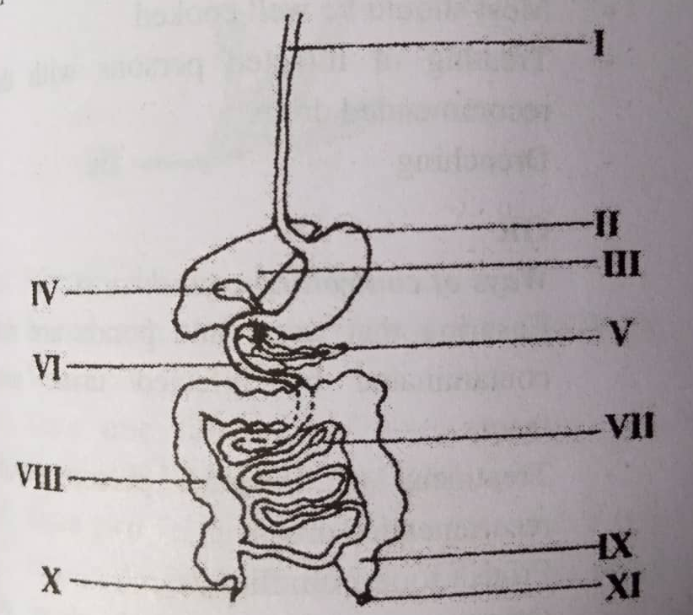
- Identify the part of the human body illustrated.
- Name the parts labelled I, II, III, IV, V, VI, VII, VIII, IX and X
- Describe the digestive process that occur in VI
- i) List two enzymes secreted by the part labelled II
ii) State one function of each of the two enzymes you have listed in (d (i))
Answers
1a
Digestive system of human, or the gut or Alimentary Canal

1b
I - Oesophagus or Gullet
II. – Stomach
III. – Liver
IV – Gall Bladder
V - Pancreas
VI – Duodenum
VII – Ileum
VIII – Colon or Large intestine
IX – Rectum
X – Appendix
1c
Digestion process that happens in VI
The Gall bladder releases bile into the duodenum (VI) and pancreas also releases pancreatic juice into it.
The bile emulsifies fat that is break fat or oil into small droplets , the bile also changes the PH of food into alkaline by neutralizing the Gastric acid or stomach acid.
The pancreatic juice releases Amylase which converts starch to maltose
Trypsin which converts proteins into polypeptides.
Lipase converts emulsified fats into fatty acids and glycerol

d.(i)
Enzyme secreted by the parts labelled II
Pepsin and renin

d (ii)
Functions of the enzymes
Pepsin changes protein to peptones or polypeptides
Renin clots milk proteins or converts milk proteins into curd protein.

- The illustration below is the digestive system of a farm animal
Study carefully the figure and answer the questions that follows.

- i) Name the parts labelled I, II, III, IV, V and VI
ii) State one function each of the parts labelled I, V and VI
- i) Name two farm animals that possess the digestive system illustrated
ii) What is the general name given to the farm animals in (i) above.
- i) Name one parasite that affects the part labelled IV.
ii) State two ways of controlling the parasite named in (i)
Answers
2ai
- Gullet or oesophagus
- Rumen
- Abomasum
- Duodenum or small intestine
- Colon or large intestine
- Rectum
2aii
Functions of the parts labelled I, V and VI
I – serves as the passage way of food from the mouth to the rumen
V – Absortpion of water into the blood stream occurs here
VI – Temporal storage of undigested food
2bi
Farm animals that possess the digestive system illustrated
Cattle or cow
Sheep
Goat

2bii
Ruminants
2ci
Parasites that affect the part labelled IV
Tapeworm
Roundworm
Hookworm

2cii

Ways of controlling tapeworm
Meat should be well cooked
Treating the infected person with drugs
Drenching

Ways of controlling roundworm
Protect food from flies
Treatment of infected person with drugs
Drenching

Ways of controlling hookworm
Protection of food from flies
Treatment of infected person with drugs
Drenching

- The illustration below is the digestive system of a farm animal
Study the illustration carefully and answer the questions that follows.

- Identify the digestive system
- Name each of the parts labelled I, II, III, IV, V and VI
- State one function of each of the parts labelled I, II, III, IV and VI
- State two features of the parts labelled V that helps in the performance of the function stated in (C)
Answers
3a
Digestive system of a monogastric animal or Digestive system of Bird or Fowl, or chicken or poultry.

3b
- proventriculus or true stomach
- Large Intestine or colon
- Cloaca
- Duodenum / duodenal loop or small intestine or jejenum
- Ventriculus
- Crop
3c
Functions of the parts labelled

- Stores food and also digestion start from here
- Absorbs water from food into the blood stream
- Passage way for excretory products or passage way for undigested food or passage way for egg.
- Digestion of food occurs here, secretions of enzymes to digest starch, protein etc.
- Store food and water, Grinds food
3d)
Have stones present that helps to grind food since the organism does not have teeth

- Examine the structures below carefully and answer the questions that follow
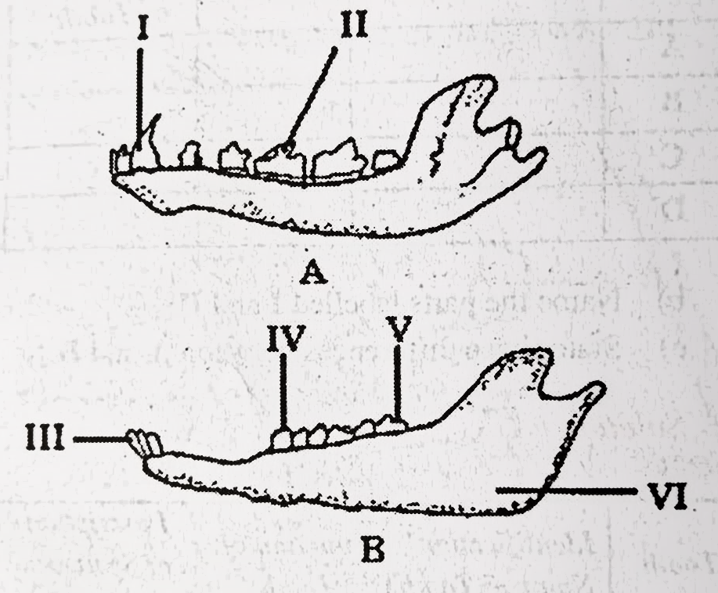

- Identify each of the strutures A and B
- Name each of the parts labelled I, II, III and IV
- Give one function each each of the parts labelled I, II, III
- Name two animals in each case in which each of the structures A and B can be found.
- In a tabular form give four observable differences between structures A and B
- i) What name is given to the part labelled V in adult human beings?
- Explain how the name you have given in (i) ia suitable for the structure.
Answers
4a
A – A lower Jaw of a Carnivore
B – Lower Jaw of a herbivore

4b
- Canine
- Carnassial teeth
- Incisor
- Premolar

4c
I – Used for seizing or killing prey or tearing meat
II – Used for grinding or chewing or slicing of flesh or cracking bones.
III – Used for cutting or gnawing of grass
4d
Animals in which structures can be found
- Dog, Cat, Lion, Tiger
- Goat, Sheep, Cow

Difference between A and B

Structure A | Structure B
Canine tooth present | Canine tooth absent
Carnassial tooth present | Carnassial tooth absent
Diastema absent | Diastema present
Posterior end of jaw bones has three dents | Posterior end of jaw bone has two dents

4f(i)
i) Wisdom Tooth
4f(ii)
Name is suitable because the tooth does not appear until the individual is an adult

