ACADEMY OF CHRIST THE KING S.H.S
INTEGRATED SCIENCE CLASS TEST - DURATION 30MINS
NAME:………………………………………………………. …… CLASS………..
- Which of the movements occur when the arm of human is bent?
- Biceps relaxes and triceps contracts
- Biceps contracts and triceps relaxes
- Both biceps and triceps relax
- Both biceps and triceps contract
- Exhaled air may readily put off a burning candle because it contains high levels of
- Oxygen and Nitrogen
- Nitrogen and heat
- Heat and oxygen
- Carbon dioxide and moisture
- The rate at which green plants release carbon dioxide during the night is higher than that during the day because
- Light inhibits respiration
- Stomata are closed during the day
- Darkness is required for respiration
- The carbon dioxide produced during the day is used up
- When a potted seedling is locked up in a cupboard for about twelve hours it loses all the starch in its leaves because
- The starch is converted to glucose in the dark
- The starch is oxidized to liberate energy
- Heat in the cupboard causes the starch to melt
- Darkness destroys the starch completely.
- A boy who got trapped in a cupboard died because
- All the air in the cupboard was used up.
- Only nitrogen gas was left in the cupboard
- The greater part of oxygen in the cupboard was used
- Noble gases run shot in the cupboard.
- Which of the following structures in the respiratory system of humans protects the lungs?
- Diaphragm
- Larynx
- Rib
- Trachea
- Gum Bleeding in humans is caused by the deficiency of
- Vitamin A
- Vitamin B1
- Vitamin C
- Vitamin D
- Which of the following vegetables provides the largest amount of roughage in diet of humans?
- Beans
- Cabbage
- Carrot
- Pepper
- One of the chemicals used to test for the presence of protein is
- Benedict’s solution
- Fehling’s solution
- Millon’s reagent
- Anhydrous copper sulphate

- Which of the following meals appear to be a more balanced diet?
- Yam, vegetable stew mixed with egg and orange slice
- Rice, palm nut soup, and yoghurt.
- Fried plantain, beans and coca cola drink
- Kenkey with shito, fried fish and ice cream

SECTION B
PRACTICAL WORK
- Study carefully the diagrams of the different types of human teeth below and answer the questions that follows.
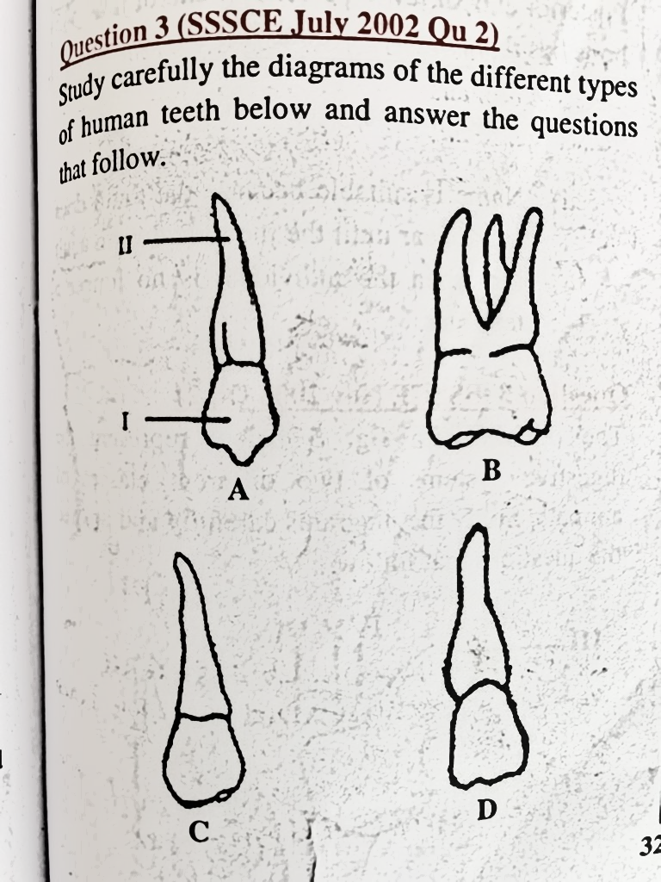
- Name the parts labelled
I…………………………….

II…………………………..
- Identify the type of tooth labelled A, B, C and D
A…………………………..
B………………………….
C…………………………..
D………………………..

- The set-up below is an experiment to illustrate respiration of a small mammal. Study the set-up carefully and answer the questions that follow.
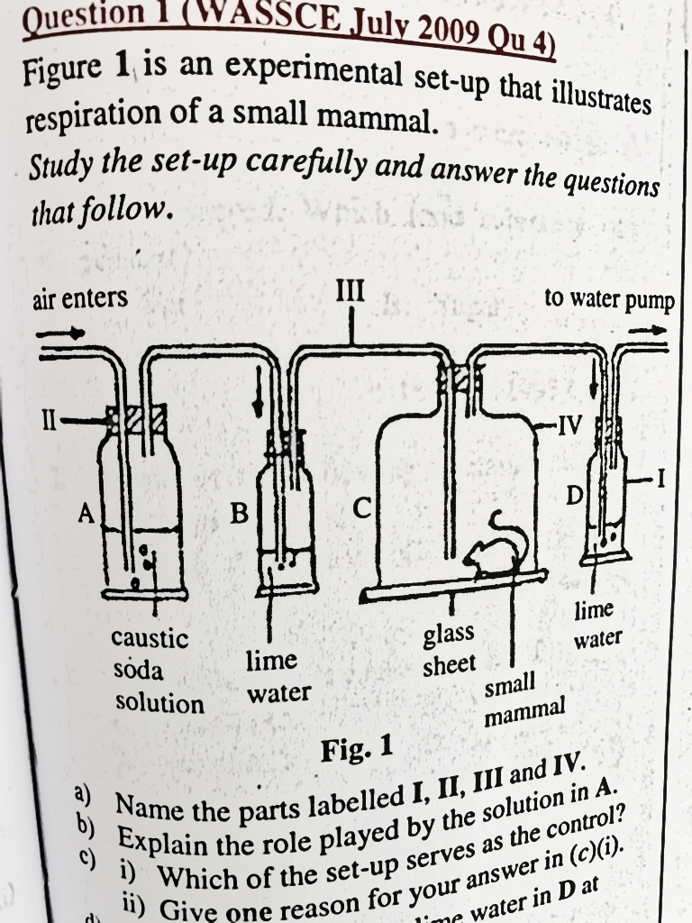
a). Name the parts labeled
I……………………………….
II……………………………….
III……………………………..
IV……………………………..
b) Explain the role played by the solution in A
…………………………………………………………………………………………………………………………………………………………

c) Suggest an aim for the experiment
……………………………………………………………………………………………………………………………………………………………
d) What happens to the lime water in D at the end of the experiment?
………………………………………………………………………………………………………………

e) State one precaution to be taken during the experiment
………………………………………………………………………………………………………………….
3. Food substances labelled J, K and L were tested with various chemicals in a school laboratory. The results obtained are tabulated below.

- What inferences would you make about the food substances from the result above.
J……………………………
K……………………………..
L…………………………….

