PROJECT WORK AND READING ASSIGMENT

Reading Assignment
Photosynthesis
3.1 The process of photosynthesis 3.2 Conversion of light energy to chemical energyy
Acids, bases, and salts
7.1 Simple definition of acids, bases, salts 7.2 Physical and chemical properties of acids, bases and salts 7.3 Examples of chemical substances classified as acids, bases or salts 7.4 Methods of preparation of salts 7.5 Acid-base indicators 7.6 Determination of pH of a given solutions
Water
9.1 Physical and chemical properties of water 9.2 Hardness and softness of water. 9.3 Treatment of water for public consumption
Metals and non-metals
10.1 Classification of materials 10.2 Uses of metals, semi-metals and non-metals 10.3 Alloys 11. Exploitation of minerals 12. Rusting 12.1 Process of rusting 12.2 Prevention of rusting
Organic and inorganic compounds
13.1Classification of chemicals as organic and inorganic 13.2 Neutralization And esterterification 13.3 Petrochemicals
. Life cycles of pests and parasites
4.1 Types of pests and parasites 4.2 Life cycles of some pests and parasites of human, plants and farm animals 5.
Crop production
5.1 General principles of crop production 5.2 Production of crops.
General principles of farm animal production:
6.1 Main activities involved in farm animal production 6.2 Ruminant production 6.3 Production of non-ruminant
Excretory system
7.1 Excretory organs 7.2 Disorders of urinary systems in humans
Light energy
7.1 Reflection and refraction of light 7.2 The mammalian eye 7.3 Dispersion of light 7.4Primary and secondary colours 7.5 Electromagnetic spectrum.
Ecosystem
  - Basic ecological terms 1.2 Types of ecosystem and their components 1.3 Food chain and food web 2.
Atmosphere and climate change
2.1 Regions of atmosphere 2.2 Human activities and their effects on the atmosphere 2.3 Atmospheric pollutants 2.4 Green house effect.
PROJECT WORK,
MUST BE DONE ON AN OFFICIAL PAPER ONLY
- The illustration below is part of the human body. Study the figure carefully and answer the questions that follows
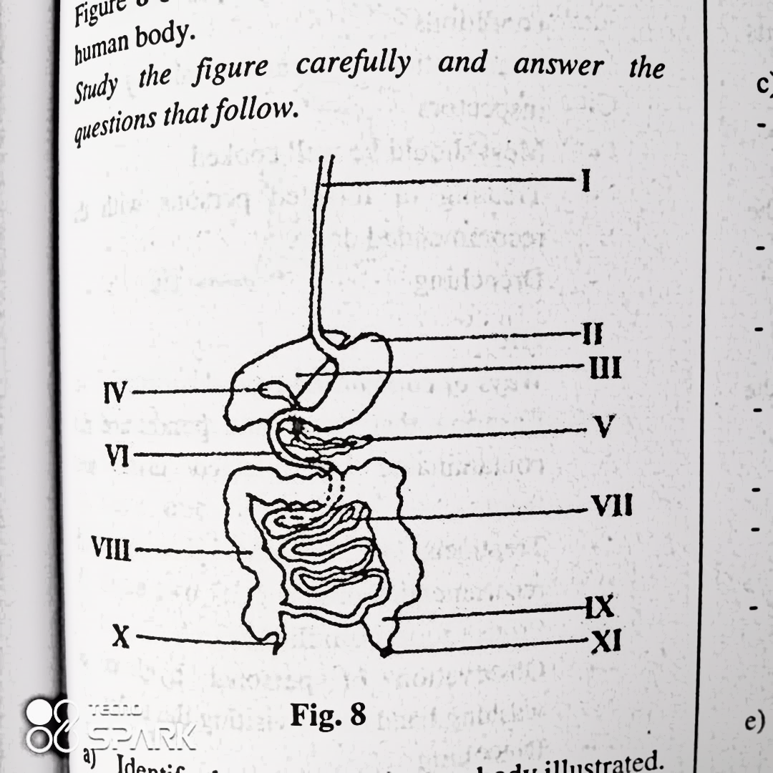
- Identify the part of the human body illustrated.
- Name the parts labelled I, II, III, IV, V, VI, VII, VIII, IX and X
- Describe the digestive process that occur in VI
- i) List two enzymes secreted by the part labelled II
ii) State one function of each of the two enzymes you have listed in (d (i))
- Examine the structures below carefully and answer the questions that follow
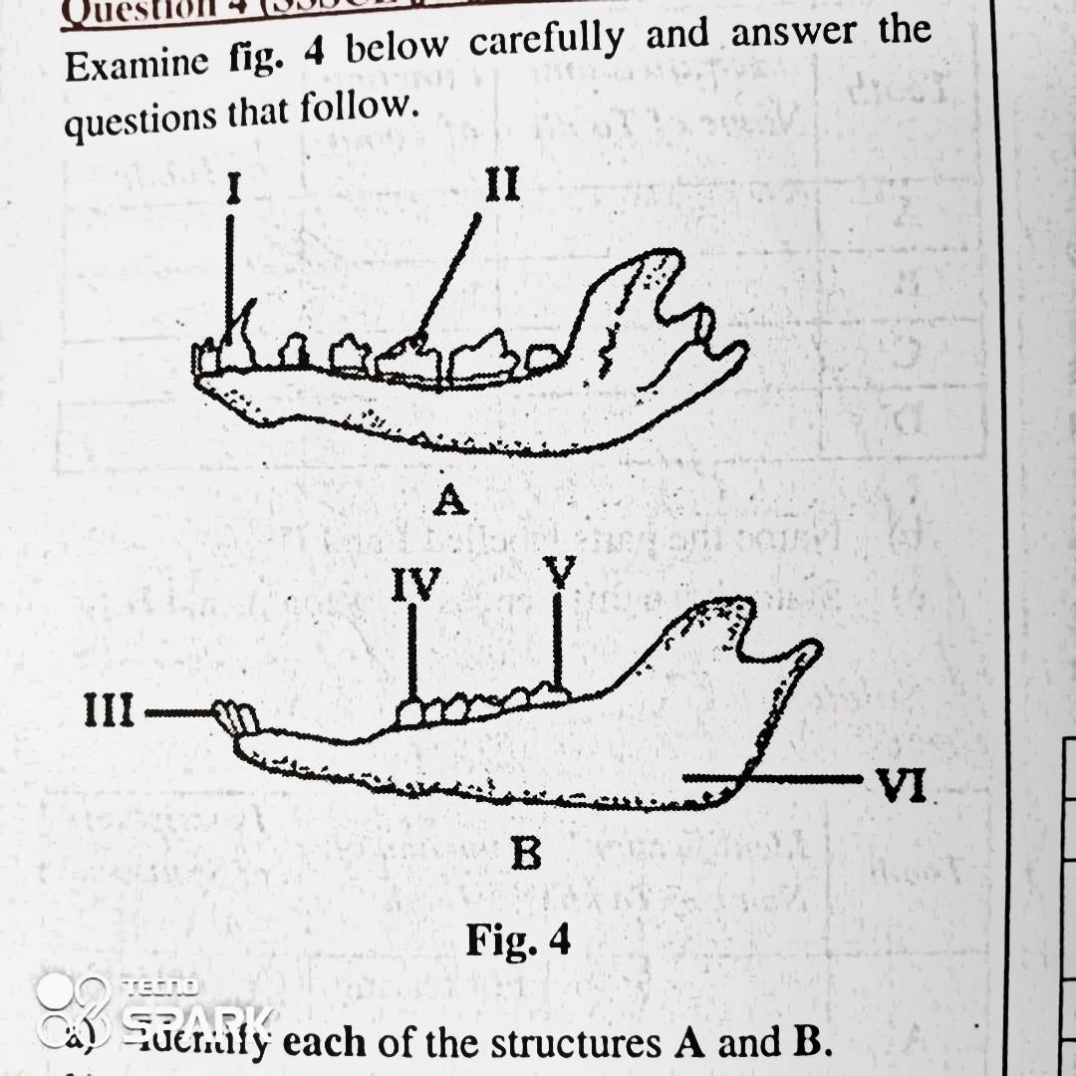
- Identify each of the structures A and B
- Name each of the parts labelled I, II, III and IV
- Give one function each each of the parts labelled I, II, III
- Name two animals in each case in which each of the structures A and B can be found.
- In a tabular form give four observable differences between structures A and B
- i) What name is given to the part labelled V in adult human beings?
- Explain how the name you have given in (i) ia suitable for the structure.

