BASIC 7
WEEKLY LESSON PLAN – WEEK 3
Learning Indicator(s) | B7.4.4.1
Performance Indicator | B7.4.4.1.1 State and explain Newton’s First Law of motion
Week Ending | 30-09-2022
FORM | B.S.7
Subject | Integrated Science
Reference | Curriculum, Teachers Resource Pack, Learners Resource Pack.
Teaching / Learning Resources | Textbook, Pictures, Word Chart, Video Player.
DAYS | PHASE 1 : STARTER | PHASE 2: MAIN | PHASE 3: REFECTION
MONDAY  26-09-2022 | Learners brainstorm to explain the meaning of Motion. | - Discuss with Learners Newton’s Law of Motion.  - Learners are to be guided to explain Newton’s Law of Motion.  - Show Learners a tutorial video show of Newton’s Law of Motion.  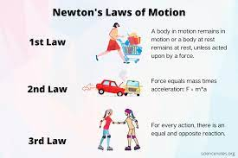  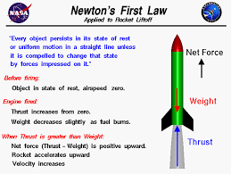 | Core Competencies;  - Ability to ascertain when information is needed and be able to identify, locate, evaluate and effectively use them to solve a problem.  - Adhere to behavioural protocols that prevail in cyberspace. Knowledge and recognition of ethical use of information  - Explain ideas in a clear order with relevant detail
THURSDAY  29-09-2022 | Through questions and answers, review Learners knowledge on the three (3) laws of Motion. | - Guide Learners to apply the Formula for calculating Newton’s First law of motion.  - Discuss with Learners the Formula for calculating the second and the third laws of Motion.  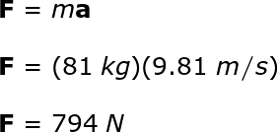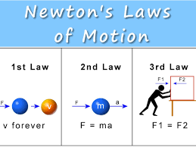  Equation of Newton’s second Law of Motion;  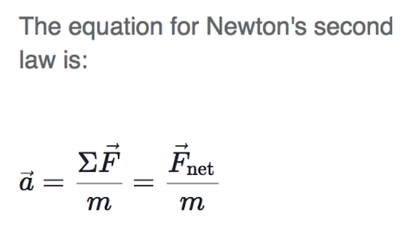 | Core Competencies;  - Ability to merge simple/ complex ideas to create novel situation or thing. Recognise and generalise information and experience; search for trends and patterns. Being open-minded, adapting and modifying ideas to achieve creative results

