WEEK ENDING………30/09/2022……………………………………
SUBJECT…INFORMATION AND COMMUNICATION TECHNOLOGY
REFERENCE…SYLLABUS(CRDD,2007), ICT FOR JHS ……………….
FORM……………..BASIC 8……………WEEK…………3………………..
DAY/DURATION | TOPIC/SUB-TOPIC/ASPECT | OBJECTIVES/R.P. K | TEACHER-LEARNER ACTIVITIES | T/L MATERIALS | CORE POINTS | EVALUATION AND REMARKS
TUESDAY  27-09-2022  1:20PM – 2:40PM  80min | TOPIC  Accessing Information  SUB-TOPIC  Access information using Website address | OBJECTIVE  By the end of the lesson the Pupil will be able to;  - Explain the meaning of Website.  - Identify the features of a website address.  R.P.K  Pupils have been browsing through the internet using website addresses. | INTRODUCTION  Pupils brainstorm to mention examples of website addresses.  ACTIVITIES  - Assist Pupils to visit webpages by using website addresses.  - Discuss the features of website address with the Pupils.  CLOSURE  Through questions and answers, conclude the lesson. | - Computer connected the internet  - Word Chart  - Pictures | Meaning of Website;  a group of World Wide Web pages usually containing hyperlinks to each other and made available online by an individual, company, educational institution, government, or organization.  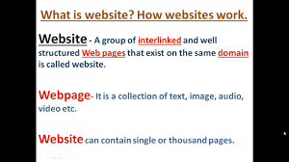  Examples of a Website address;  https://www.tubidy.com  https://www.ghanaweb.com  https://uew.edu.com  https://www.yahoo.com  Features of a Website;  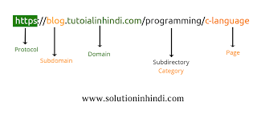  - Scheme  - subdomain  - top-level domain  - second-level domain  - subdirectory | Exercise;  - Explain the meaning of a website address.  - Write 5 examples of a website address.  Assignment;  Explain 5 features of a website.
THURSDAY  29-09-2022  8:05AM – 9:15AM  70min | TOPIC  Accessing Information  SUB-TOPIC  Typing correct Website address. | OBJECTIVE  By the end of the lesson the Pupil will be able to;  - Type correct website address.  - State 2 effects of typing a wrong website address.  RPK  Pupils have already been taught the features of a website address. | INTRODUCTION  Review Pupils knowledge on the previous lesson.  ACTIVITIES  - Pupils brainstorm to type website addresses.  - Discuss the effects of typing a wrong website address with the Pupils.  - Assist Pupils to explain typo squatting.  CLOSURE  Pupils in groups practice typing correct website addresses. |  | Effects of Typing a wrong Website Address;  Just one wrong keystroke could send you to a typo squatter's look-alike site that can install malware, steal sensitive personal and financial information, or even lock up your computer.  Meaning of Typo squatting;  Typo squatting, also known as URL hijacking, is a form of cybersquatting (sitting on sites under someone else's brand or copyright) that targets Internet users who incorrectly type a website address into their web browser (e.g., “Gooogle.com” instead of “Google.com”). | Exercise;  - What is Typo Squatting?  - Discuss 2 effects of typing a wrong website address.  REMARKS

