WEEK ENDING………30/09/2022……………………………………
SUBJECT…MATHEMATICS
REFERENCE…SYLLABUS(CRDD,2007), MATHS FOR JHS ……
FORM……………..BASIC 8……………WEEK……3……………..

DAY/DURATION | TOPIC/SUB-TOPIC/ASPECT | OBJECTIVES/R.P. K | TEACHER-LEARNER ACTIVITIES | T/L MATERIALS | CORE POINTS | EVALUATION AND REMARKS
TUESDAY  27-09-2022  1:20PM – 2:40PM  80min | Topic;  Ratio and Proportion  Sub-Topic;  Scale Drawing using Proportion. | By the end of the lesson the Pupil will be able to;  use proportion to  find lengths,  distances and  heights involving  scale drawing  RPK  Pupils can calculate ratio and proportion questions. | Introduction  Activities  - Guide pupils to find lengths, distances and heights  involving scale drawings.  - Pupils individually to practice using proportion to find lengths, distances and heights with scale proportion.  Closure  Through questions and answers, conclude the lesson. | Pictures, Chart, Scale, beam balance. | 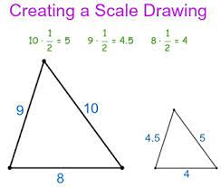  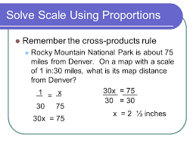 | Exercise;  Using proportion with scale drawing;  - Which pairs of ratios are Proportional;  - 3/5,4/8  - 6/12.3/6  - 2/5.10/15  - 5/15,3/9
THURSDAY  29-09-2022  8:05AM – 9:15AM  70min | Topic;  Ratio and Proportion  Sub-Topic;  Proportionality in Geometry. | Objective;  By the end of the lesson the Pupil will be able to;  Write proportionality statements in Geometry.  RPK  Pupils have been taught lessons on Geometry in basic 7. | Introduction  Review Pupils knowledge on the previous lesson.  Activities  - Discuss examples of statements in Proportionality with the Pupils.  - Engage Pupils in solving questions on Proportionality in Geometry.  Closure  Through questions and answers, conclude the lesson. | Pictures, Chart, Scale, beam balance. | Proportionality;  The term proportionality describes any relationship that is always in the same ratio. The number of apples in a crop, for example, is proportional to the number of trees in the orchard, the ratio of proportionality being the average number of apples per tree.  Eg. Statement: The line drawn parallel to one side of a triangle and cutting the other two sides divides the other two sides in equal proportion.  Given: Consider a triangle ΔABC, as shown in the given figure. In this triangle, we draw a line DE parallel to the side BC of ΔABC and intersecting the sides AB and AC at D and E, respectively.  Construction: In the above diagram, create imaginary lines where you can Join C to D and B to E. Draw perpendicular DP perpendicular to AE and EQ perpendicular to AD.  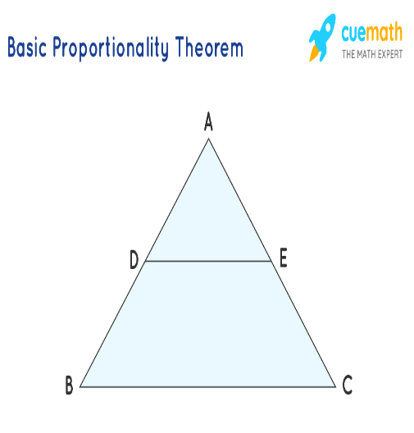 | REMARKS

