WEEK ENDING………30/09/2022……………………………………
SUBJECT…INTEGRATED SCIENCE
REFERENCE…SYLLABUS(CRDD,2007), SCIENCE FOR JHS ……
FORM……………..BASIC 8……………WEEK……3….……………..
DAY/DURATION | TOPIC/SUB-TOPIC/ASPECT | OBJECTIVES/R.P. K | TEACHER-LEARNER ACTIVITIES | T/L MATERIALS | CORE POINTS | EVALUATION AND REMARKS
TUESDAY  27-09-2022  1:20PM – 2:40PM  80min | Topic;  Electrical Energy  Sub-Topic;  Ways of conserving Electric Energy. | By the end of the lesson the Pupil will be able to:  explain ways of conserving electrical energy.  RPK  Pupils have been using electric appliances at home. | Introduction;  Review Pupils knowledge on the previous lesson.  Activities;  - Guide Pupils to identify ways of conserving electric energy at home.  - Pupils brainstorm to explain ways conserving electric energy at work places.  - Pupils in groups to discuss the importance of conserving electric energy.  Closure;  Through questions and answers, conclude the lesson. | Battery, Switch, led bulb, Wire, Pictures. | 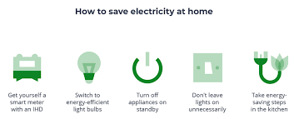  Ways of Conserving Electric Energy;  - Turn off unnecessary lights.  - Use natural light.  - Use task lighting.  - Take shorter showers.  - Turn water off when shaving, washing hands, brushing teeth.  - Fix that leaky faucet.  - Unplug unused electronics.  - Ditch the desktop computer. | Exercise;  1.State 5 ways of conserving Electric Energy  2. Explain 4 importance of conserving electric energy.
THURSDAY  29-09-2022  8:05AM – 9:15AM  70min | Topic;  Basic ELectronics  Sub-Topic;  Compositions and types of Transistors. | Objective;  By the end of the lesson, the Pupil will be able to;  describe the composition and types of transistors  RPK.  Pupils can identify a transistor since they taught about transistors at basic 7. | Introduction;  Pupils brainstorm to explain the meaning of a transistor.  Activities;  - Assist Pupils to identify the two P-N junctions of a transistor.  - Discuss with Pupils about the meanings of Emitter lead(e), Base lead(b) and Collector lead(c).  - Assist Pupils to explain the types of transistors.  Closure;  Through questions and answers, conclude the lesson. |  | Compositions of a transistor;  Transistors have three main parts.  - Emitter (negative lead); they emit free electrons into the base.  - Base; the passes most of the injected electrons to the collector.  - Collector (positive lead); they take electrons from the base.  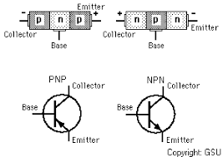  Types of a Transistor;  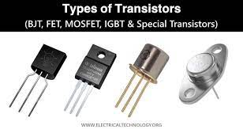  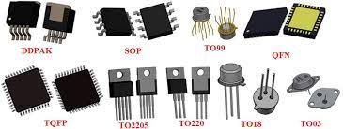  - bipolar transistors (bipolar junction transistors BJTs)  - field-effect transistors (FETs)  - insulated-gate bipolar transistors (IGBTs). | Exercise;  1.Explain the following;  i. Emitter  ii. Base  iii. Collector  2. Explain the types of a transistor.  REMARKS

